### **User Guide: Save Publish Tool**

* **Overview**

**Save Publish Tool** is designed to streamline file saving, organisation, and version management for artists. This tool supports .mb, .abc, .fbx, and .usd file formats and automatically generates filenames based on the selected folder path, maintaining consistent file naming conventions. Depending on the selected folder (publish or wip), the tool will automatically decide which file types are available for saving.

### **Setup Requirements**

* **Maya**: Make sure Autodesk Maya is installed and configured to run Python scripts.
* **Folder Structure**: The tool requires a specific folder structure to function correctly and generate accurate filenames. Here’s an example: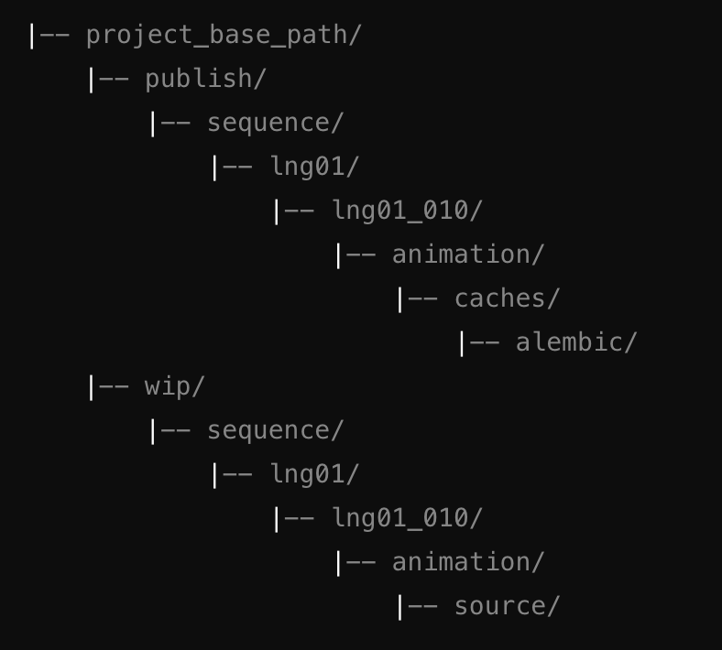

### 

### 

### **How to Use**

#### **1. Launch the Artists Time Sorting Save System**

1. Copy the provided code into Maya’s script editor and execute it.
2. The following window should appear: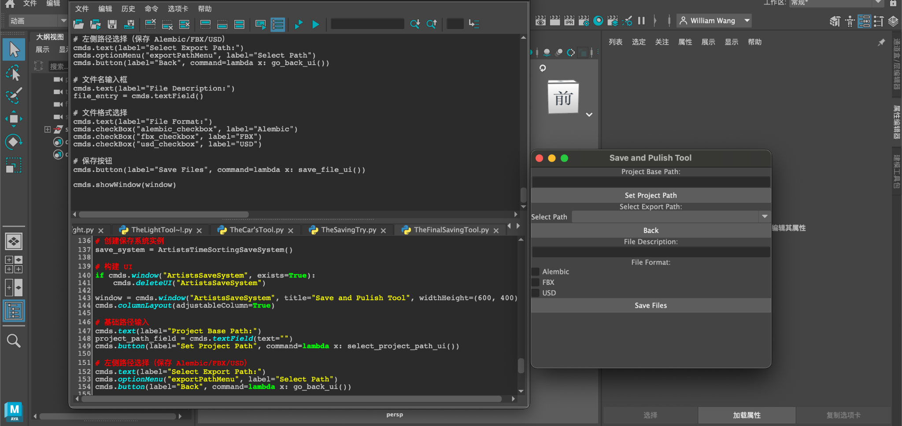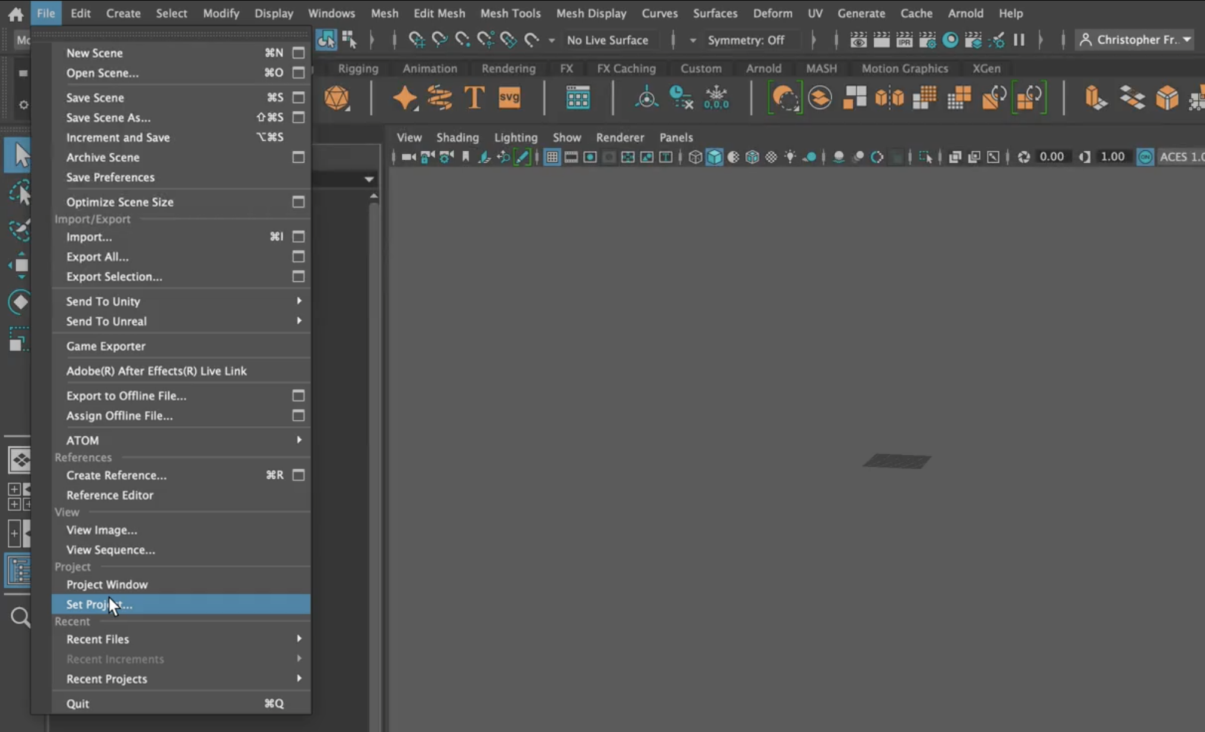

#### **2. Set the Project Path**

1. Click the **Set Project Path** button.
2. A file dialog will appear. Select the root directory of your project, such as /project_base_path/.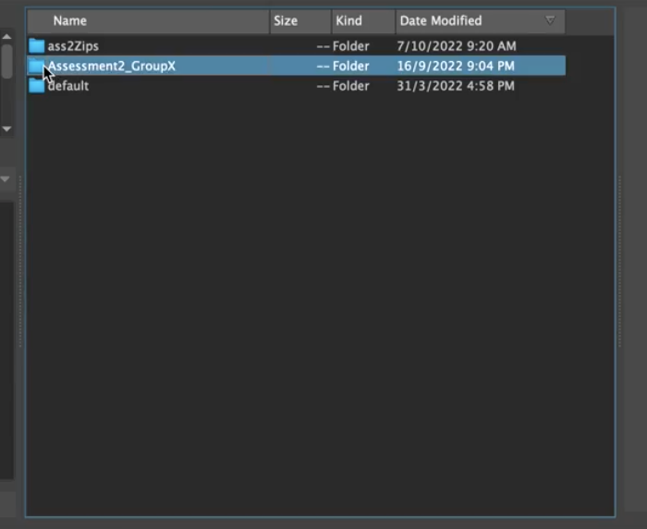
3. The current **Project Base Path** will display in the UI after setting.



#### 

#### 

#### **3. Choose Export Path**

1. Under **Select Export Path**, use the dropdown menu to select the folder where you want to save the file.

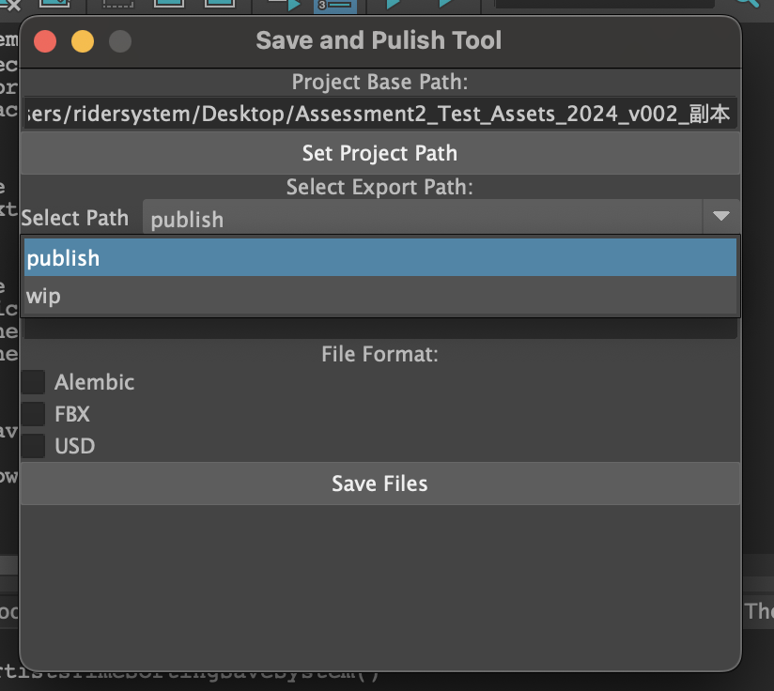

1. Use the **Back** button to navigate back up a directory if necessary.

**Note**: Depending on the folder path you choose, the system automatically determines the file types available for saving:

* **publish** folder: Supports .abc, .fbx, and .usd formats.
* **wip** folder: Only .mb format is allowed.

#### **4. Enter a File Description**

1. Type a brief description in the **File Description** field. This will be used to generate the filename.

For example, if you type "car_animation" as the description, the generated filename could look like lng01_010_car_animation_animation_v001.abc.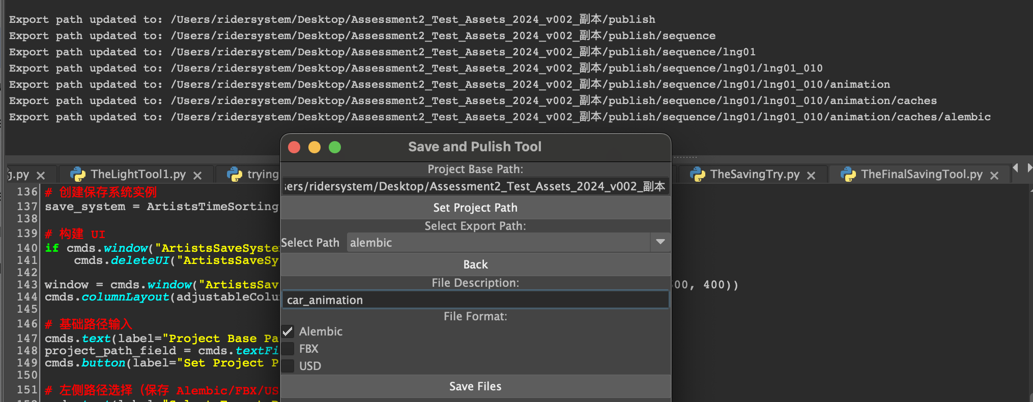

#### **5. Select File Formats**

1. In the **File Format** section, choose the file formats you wish to save. Options will vary based on your selected folder.  
   **Note**: If you’re in the publish folder, you can choose from .abc, .fbx, and .usd; in the wip folder, only .mb is available.

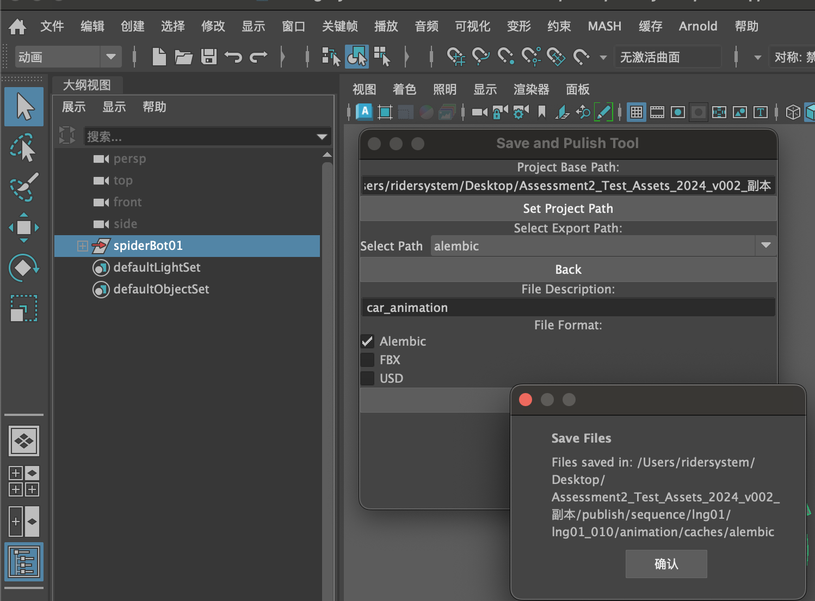

#### **6. Save the File**

1. Click the **Save Files** button.
2. The system will generate a filename and save the file in the specified directory. Example filenames:
   * In the **publish** folder: lng01_010_description_animation_v001.abc
   * In the **wip** folder: lng01_010_animation_v001.mb

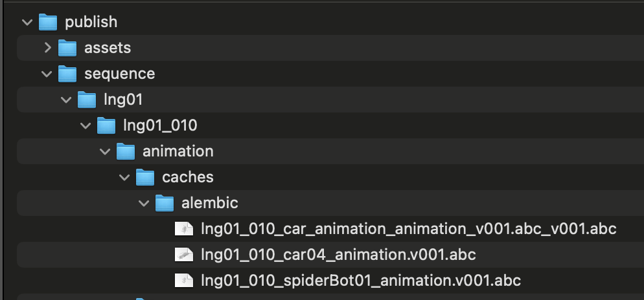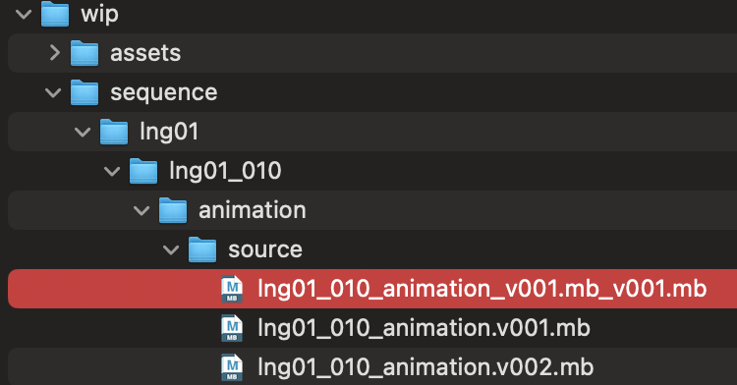

### **Troubleshooting**

### **Problem: File cannot be generated or path is incorrect**

* + Verify that the project path and export path are set correctly and match the expected folder structure.

1. **Problem: Error “No valid root nodes were specified” when saving**
   * Ensure you’ve selected at least one valid scene node before saving .abc, .fbx, or .usd files.

* **FAQ**
  + **Q**: “Why doesn’t my filename match the example format?”
    - **A**: This could be due to discrepancies in the filename generation logic. The function generate_file_name() uses folder names to build the filename. Double-check that your directory structure aligns with the expected format, and adjust the function if necessary.

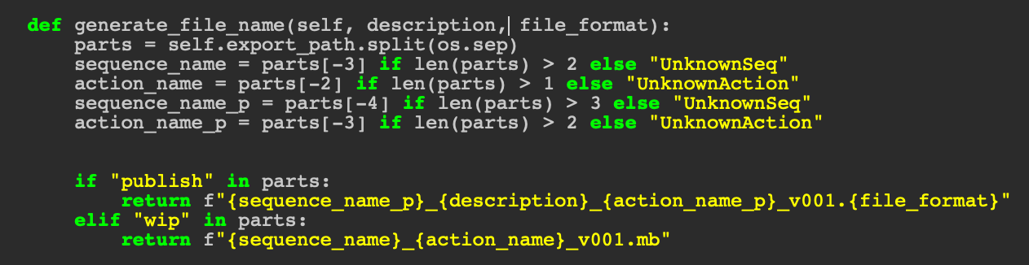

* + **Q**: “Can I set the file name manually?”
    - **A**: The tool automatically generates file names based on the folder structure to ensure consistency, so manual naming is not supported.